Solar and Lunar Meditations

These are nice meditations to do as the full moon ripens, or under the light of the bright, yellow moon. The third, a breathing meditation, is also great to do at the solstices.
ONE
1) Create a circle of yellow flower petals or cornmeal, or create a circle of yellow ribbon.
2) Place a beeswax candle in each of the four directions. Beeswax represents internal richness and the color yellow signifies the fire of the sun and the fire of the sun reflected on the moon.
3) Sit in the center of this circle and meditate upon the sacred plants and animals, and all that is sacred in nature.
4) When you are complete, offer the illumined water to the Earth or to a nearby water source. Feel and express your gratitude.
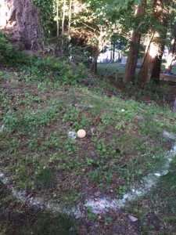
TWO
1) Create a circle of yellow flower petals or corn kernels or cornmeal, or create a circle of yellow ribbon.
2) Place a beeswax candle and a fresh glass of water in the center, and then enter the circle and sit next to these.
3) Say a prayer for troubled parts of the world. Radiate love to the Earth.
4) When you are complete, offer the illumined water to the Earth, or to a nearby water source. Feel and express your gratitude.
BREATHING MOONLIGHT and SUNLIGHT
Sit comfortably and take some nice deep breaths until you feel relaxed. Take your time. Feel fully present in your body and in the room – or outside, wherever you sit. When you feel ready, here is how to do the practice:
1) Expel a natural breath out, releasing whatever is ready to discharge from you (stress, worry, etc). Know that this is immediately transmuted by the life force all around you.
2) Imagine that as you breathe out (and follow your breath with your awareness), you can travel all the way to the sun.
3) Sense the sun’s warmth and light; then breathe these nourishing forces all the way back to you on the next inbreath, so they penetrate every pore as well as enter you with the breath. Feel this light and energy flood every part of you physically, mentally, emotionally and spiritually. Really feel it.
4) On your next outbreath, again release whatever is ready to discharge with the breath, knowing it is immediately transmuted into pure life force energy.
5) Follow your breath out, with your awareness, imagining that you can breathe, and expand with your awareness, all the way out to an illumined full moon.
6) Sense the warmth and light of the moon’s glow; then breathe in these nourishing forces bringing them all the way back to you from the moon, so they penetrate every pore as well as with the breath. Feel this light and energy flood every part of you physically, mentally, emotionally and spiritually. Really feel it.
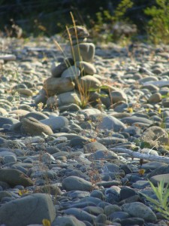
Repeat, alternately breathing with solar and lunar forces for 6-8 complete cycles of breathing. Do not force the breath, just expel and inhale gently and naturally. You may begin to notice that breathing with the moonlight and sunlight, each have their unique qualities. When you feel filled with light after half a dozen to 8 or so full breathe-and-retrieve cycles, come to completion – allow the practice to gently dissolve. Stay with the feeling of light, warmth and nourishment. Make it real. Feel that you radiate nourishing, loving light, that naturally benefits those beyond you and all sentient life – lighting pathways for those who are lost, in turmoil, pain, or confusion. This is not personal light, but source light. When complete, say a simple closing prayer, do some gentle stretching and drink a glass of fresh water. Now, go out and make an offering to the Earth of bread or yellow flower petals or cornmeal. Feel and express your deep gratitude to the living beings of the sun, moon, and Earth. Intend that whatever benefit you may have received, also radiate goodness beyond you.

