New Moon Ceremony

Ancient shamanic peoples honored the Earth and they also harmonized through ritual and ceremony – with the seasonal, as well as celestial cycles. You’ll enjoy this ceremony, which honors the energy that becomes available with the New Moon phase.
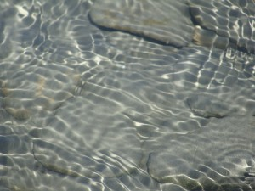
Please regard the New Moon as that first arc of light – the crescent of the newly waxing moon, not the moon in its invisible phase as noted in your Gregorian calendar. If that sounds confusing – notice how you feel when that moon is invisible and how you feel when that slim, yet bright crescent appears in the sky! The New Moon is the return of light!
Feel free to adjust this outline if the moon prods you to create new ways of performing this simple yet powerful ceremonial. Ask the living being of the moon to help you follow your heart!
Remember – the New Moon is marked by the appearance of the waxing crescent in the night sky.
On the day of the New Moon, fill a physically clean and energetically cleansed glass or ceramic or wooden bottle or container with the purest drinking water you have accessible. Use fresh spring or well water or filtered water from the faucet that you drink from, and be sure you have a well-fitted cap for the container or bottle. Add to the water, the following:
*Spiritual symbols that you work with and are drawn to invoking, and/or a blessing for the water.
*A song, or prayer or spoken words to welcome wishes, longings, creations personal and collective, that desire to be birthed and loved into manifestation in this New Moon phase such as: new ideas and fresh ways of relating and new habit patterns and stories and imprints and choices, a creative project, a personal dream, a healing wishes for you or your family or community, dreams for nature and the Earth. Ask the water to hold the wishes so they can absorb moon and starlight. Ask the New Moon to help you, and all humans, to birth new creations and healthy ways to be that nourish all life.
Place your glass or ceramic bottle or container of water under the new crescent and under starlight for one full night, allowing the informational light stream from the moon, stars and other celestial bodies to energize this water, and to empower the wishes it carries. Remember to place the bottle on a windowsill instead of outside, if you’re concerned that it will freeze if left outside through the night or the next morning. (Remember to keep the cover secure, should you intend to drink the water following the ceremony.)
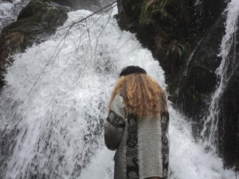
On the following morning, thank the moon and the Earth and the water. Offer a few sprinklings of your New Moon Water to the Earth with a simple prayer of gratitude. Invite the spirit of the Earth to use this purified, light-filled water as an alchemical trigger to empower new, creative dreams for all life on Earth. As you sprinkle water blessings, envisage the lands, airs and waters as pristine, clear, healthy – radiant with life force and beauty. You may sing or state this if you are drawn. Imagine humans living in balance with animals. Envision humans remembering and sharing with our starry sisters and brothers. Feel these wishes in your body, as if they are true now. Feel them emanate deeply into the Earth’s core as well as far out to the furthest star, as you sprinkle wakeful, illumined water onto the Earth – seeding new possibility for all life.
In the next moments, you may want to close your eyes and drink a sip of the New Moon Water whilst envisioning and feeling the liquid light cascading through your body, illumining and transforming and loving any remaining shadow places and filling every cell, organ, bone, ligament, muscle, tissue and so forth, as well as your heart center and emotional body with pure luminosity, bringing calm spaciousness to your mind and feelings. Feel possibility – see and feel new dreams for life, as if they are real for you right now. Really feel this in your body and heart.
Feel your love and gratitude for all the Earth’s waterways and water bodies. Feel your love and gratitude for the moon, for our Mother Earth and all of nature, for people, and for all life seen and unseen.
You can later use this New Moon water in ceremony and for blessings, offerings to plants and the Earth, for personal drinking straight from the bottle or by using drops to infuse your drinking water. You may discover other ways to use this water, or they may come to you in your nocturnal or daytime dreaming.
Be sure the bottle remains clean and uncontaminated, if you choose to drink the water, or if you keep and drink the New Moon Water over time.
Again, feel free to create variations of these ceremonies, reflecting your own intuition and guidance.

