Moon Wisdom

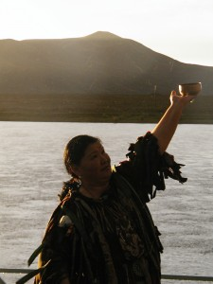
As indigenous people have done since time immemorial, we can also honor the natural cycles of the Earth and celestial bodies – we can attune to the moon’s phases. This can help us understand our own cycles and inner worlds, as well as help us find our way through the collective cycle playing out now in the world arena. The moon is a living being who impacts our physiology and consciousness. The moon can guide our inner personal, as well as outer societal development.
Here are very brief descriptions of some of the qualities that may be noted during the four main lunar cycles. Beyond what’s mentioned about them here, pay careful attention to how these phases affect YOU. Each lunar phase is different. Likewise, we are each unique and although common themes may play out, how we interpret and experience each cycle can vary widely.
The moon phases have become very powerful as we flush personal as well as collective paradigms and karma, bring to light was has lain hidden or shrouded within us and throughout the collective human story, as we individually and globally unfold this prophesied journey to reclaim greater wholeness.
We are in a profound cycle of change and the moon offers itself as a guide, to reclaim who we really are.
Dark Moon
One to three days before the New Moon, which is when the crescent of the newly waxing moon appears. Reflecting, incubating, confronting dark and shadow places and finding the light in the dark
New Moon
Marked by the appearance of the crescent moon. New beginnings, a time to nourish the creative force from the rich humus uncovered and integrated in the Dark Moon period
Gibbous Moon
Three days before Full Moon. Outdated ways and what is hidden or in denial, comes up for review. This can be a time of flushing through and an intense experience of the bubbling up old karma and demons – personally and collectively. Put your moon water out! Make offerings, prayers, and stay close to the Earth!

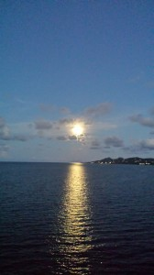
Full Moon
Release and renewal, expansive energy, the opportunity to see everything in its full light, embracing all of you – the dark and the light – as power and beauty
_______________________________________
Consciously relate to the moon’s phases and remember to put your Moon Water out! Suggestions are detailed in the book, Shamanic Reiki.
Remember that we don’t just focus on the actual New and Full Moon events, yet also those potent days that lead up to the new and full moon. Also, notice eclipses and other lunar events as, we are profoundly impacted by these energetically, as well as physiologically.

