Full Moon Water Rituals

Here are some musings about the Full Moon time, and a Moon Water ritual you can try. Or, feel free to converse with the moon to create a ritual of your own design.
As we honor each burgeoning moon, we step into a portal that illumines shadow. It’s an ideal time to honor nature, and to breathe new possibility into (transmute) outdated personal and collective beliefs, as well as to retrieve hidden gifts.
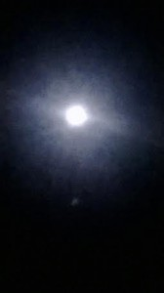
The swelling moons affect the Earth, the tides, the animals – and they affect us. We are 70-90% water, depending on where we are in the life cycle. I observe the moons have increasingly profound affect on people. They stir a lot of energy that can be challenging. The astrological forces coinciding full moon cycles can increase the impact. These rhythms and cycles demand respect.
By honoring the moon, we increase our ability to integrate powerful natural forces. We’re invited to step into nature’s mystery, and the dark and mysterious places that stir within us, as the moon swells. We can consciously open to experience each full (and dark moon) cycle as a time of initiation.
As most of us commonly associate shamanic and spiritual initiations with dismemberment, danger, and darkness, you may ask:
What’s dark about a full moon?
With so much light pouring in, we have the opportunity to see what lies in hiding, and also to embrace our, and our societies, dissociated aspects.
Each full moon portal opens a time of personal and collective cleansing. This could be of those aspects of us, and our world that are hard to face, or are denied and suppressed. Likewise it’s a time for the truth and power of nature that has been hidden and marginalized to come to light. There is such richness in the dark, moonlight liberates that richness.
Light – dark, there is always polarity, the yin and the yang.
We don’t have to go to exotic lands to undergo initiations; they are here and now, we encounter them in everyday circumstance and with every moon cycle. In paying attention we can embrace the light and dark of daily life and of natural lunar cycles to open our hearts and to live with grace, in harmony with nature.
Here’s a simple ritual to honor the burgeoning moon.

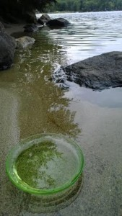
FULL MOON WATER RITUAL
Fill a physically and energetically clean glass, ceramic, or wooden bowl with the freshest water you can find (spring water, rainwater, filtered tap water, well water, stream or river water) and place it outside for three nights prior to the full moon. The main intention is to align with the moon (and nature and the waters) and honor it, and for the water to simply absorb the light/vibrations of the moon and the stars, which can later be used for blessings, cleansing, offerings and ceremony. Say a simple prayer, sing a song, or make other offerings to the moon when you place your bowl of water outside (or on a windowsill, if it’s cold outside, so the water won’t freeze) if you’d like. You can keep it simple, but do speak to the moon directly; she will hear you. In doing so, we cleanse our inner waters.
Open, and follow your heart.
Connect with that moonlight and notice what she illumines for you. Thank her for the opportunity to deepen into who you really are.
Pay attention to how the Earth and moon are calling to you during these three days before the moon is at its fullest. Listen closely and notice what you feel. Consider how to best act upon what you hear and feel; and how you can honor all life.
In this time when the sky is illumined at night, we can see more clearly. Hidden feelings and desires are illumined. Our, and the collective shadow sides can also be illumined. All bubbles up to be seen in the light.
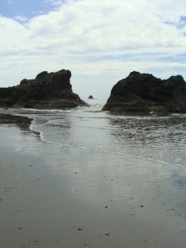
As night becomes as light as day, things may appear exaggerated. Or, you may feel things in an exaggerated manner.
If strong feelings come up in the pre-full moon phase, slow down and breathe and move your body, and connect with the Earth. This is a great time to lie down upon the Earth; she will balance you. It’s also a great time to move your body in simple ways that express feelings, or built-up energy. Consider also drumming and/or chanting – find rhythms that release and express pent up energy.
Some people like to wildly drum and dance. I prefer to stay quiet, insular and close to the Earth. See what is right for you. As we find our own ways to honor natural cycles, and ourselves, to stay grounded as our feelings intensify – our conscious actions extend benefit beyond us, as we are a collective field. We clear stuck places within to uncover the gifts they hide. We radiate more light and access the all-but-forgotten power of the Earth.
On the day of the full moon, offer with heartfelt gratitude some of your Moon Water to the Earth, to a nearby water source (river, pond, lake, stream, ocean). Consider using what remains for ceremony, blessings, etc.
Another musing, followed by a Full Moon Journey:
I feel such longing during full moons that, for decades they scared me. The same feelings would surface – that I could leave everything behind and run off with a pack of wolves into the forest. I would feel grateful when the full moon passed and I didn’t feel like a “lunatic” anymore.
Then one day, I did step out of my life to live isolated in the forest. It was dramatic, but not as weird as I imagined. A lot of people did worry that I was a lunatic, but to my surprise, it felt natural and right.
Each full moon tried to show me that living in the wild for a period of time was my destiny. I feared the moon because I feared myself. My truth was in shadow, unbeknownst and unfamiliar to me. The moon illumined it.
I had to ask myself – if we can’t integrate and express our own wild nature, how can we love and nurture forests and animals and other nature beings, as well as the wild lands, waters and winds? How can we honor the wisdom and influence of celestial bodies, which are nature and beyond taming, too?
In connecting with our wild soul – not ‘superficial’ wildness, but our deep essence – we come to respect and nourish, instead of fear and dominate nature’s wild reflection in our reality mirror. To be more of who we really are we need to find the power that hides in what we fear. When we do this, the full moon as our witness, we release bonds for more souls than us.
The full moon is a time to heal those parts of our culture, and us, which feel separate from nature. As the moons have been honored and celebrated for centuries, we tap a strong collective support now. We step into an ancient sacred circle, greetings ancestors and spirits that are just waiting for us.
Here’s an experience for you to try anytime in the few days prior to the full moon. Or, feel free to muse with the moon to create your own:

SHAMANIC JOURNEY WITH THE FULL MOON
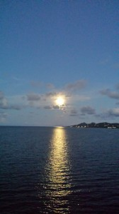
Ensure that your “moon water” bowl is outside (or on a windowsill if it’s cold out), to collect the vibrations of moon and starlight, a simple gesture that honors nature and aligns you with this moon cycle and produces water that can be used for cleansing and transmutational purposes.
Step out with bare feet under the light of the full moon near your moon water dish. If for whatever reason this is impossible you can do a shamanic journey to the moon, or simply close your eyes and imagine it, with the moon water dish on your windowsill. Sense the star and moonlight pouring into this water from the stars and full moon. Smell (or imagine smelling) the evening scents. Also, listen to nature’s sounds. If you’re in a city, focus on the natural world that’s still there – trees, air and sky. Try to listen and sense beneath the human sounds, knowing the spirit of the Earth is vast beyond human activity. Feel the power of the moon gatherings that have come before us, those conducted by all of our ancestors, and of people who celebrate each full moon across our planet now.
With your feet firmly planted on the Earth, offer a heartfelt hello and now look at (or imagine gazing at) the moon. Notice all that you see, and notice how you feel in gazing at her. Take some time.
Now, speak from the heart. Tell the living being of the moon what’s happening for you, what you fear or desire, what makes you happy or sad. Take some time to get in touch with your feelings, let them come to the surface, the moon as your witness. If there’s something that’s been lurking, allow it space and breathe with it. Don’t judge what you feel. Simple allowing is magical and nature recognizes authenticity. Just be you.
Note if something has surfaced that you need to consider more intently later. Trust your instincts and feelings; be honest by the light of this moon, which illumines what we normally can’t or don’t want to see.
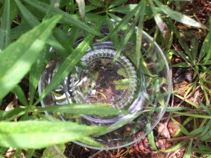
Now, take a moment to touch in with the power of this night, the felt sense of the mystery that is you, and also beyond “you”. It may not be nameable; you may barely have a sense of it. Yet, it’s there. The deep power of nature surrounds you; experience it. You may know it when you feel afraid. In this instance, may want to ask yourself:
“What is hiding?”
“What do I feel?”
Shadow places can be scary. Looking at beliefs that no longer work for us can feel threatening. Think of the moon as a healing force giving you the confidence to look squarely at these places. Everything is aglow. As we look, we may ask the moon, master of fruition:
“Are there feelings to feel? What is ripe, what is calling from the shadows? What needs to be brought to light? What needs to come to fruition within me?”
Try not to turn your back on your feelings, or get mentally busy to forget about them. Instead, breathe deeply with whatever you feel.
By the light of this moon, open your heart. Give mystery a place in our world again.
Keep breathing and get to know the texture of power and mystery, fan the fire of mystery that lives in you.
When you feel complete, thank the moon and spend some time gazing into the bowl of moon water. Say, “yes” to water, trees, land, nature beings, and the deep wild mystery of nature, and us. The water will hear you, and energize your wish.
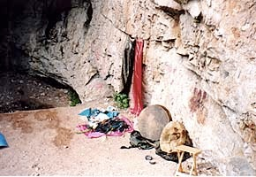
Then, say “Thank you, Moon! Thank you, Earth! Thank you, Water!”
As our ancestors have for centuries, you may like to drum, dance or move your body in ways that express and integrate the feelings that are moving through you, coinciding the heightened energies of the full moon. Move for the trees. Move for the waters. Move for the animals. Move for your ancestors. Move for those who cannot move their own bodies. Move for humans and move for trees and animals. Move for the future children of humans, trees and animals. Honor all of nature – as well as people. Believe that your movement and rhythms are vibrations and prayer - that radiate energy and goodness far and wide to every part of the Earth, as well as to the invisible realms including those beings which exist beyond our time and space.
Keep your moon water out until the day of the full moon. Then collect it to use it for ceremony, or the other suggestions above.

